Jenkins Pipeline
This document explains how to create a Jenkins Pipeline from start to end using Jenkins and GitHub.

REQUIREMENTS:-
- Install Jenkins
- Install tomcat
- Install java
- Install git
- With in manage Jenkins -> plugins->available plugins add deploy and maven plugins
- With in manage Jenkins->tools give paths of git, jdk, maven, etc

Maven Web Application Pipeline
A Maven Web Application is a Java-based web application that is built and managed using Apache Maven.
What is Apache Maven?
Apache Maven is a build automation and project management tool used mainly for Java projects. It uses a file called pom.xml (Project Object Model) to manage:
- Project dependencies
- Build lifecycle
- Plugins
- Project configuration

Step 1 : Go to Jenkins using port number

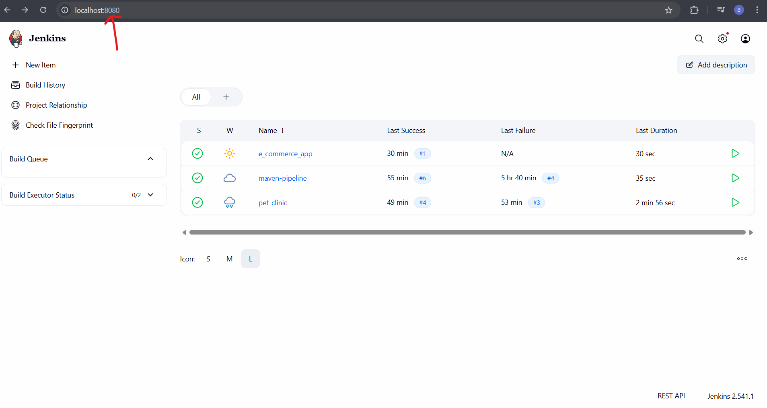
This is home page of Jenkins.

Step 2: click on “new item” to create new pipeline

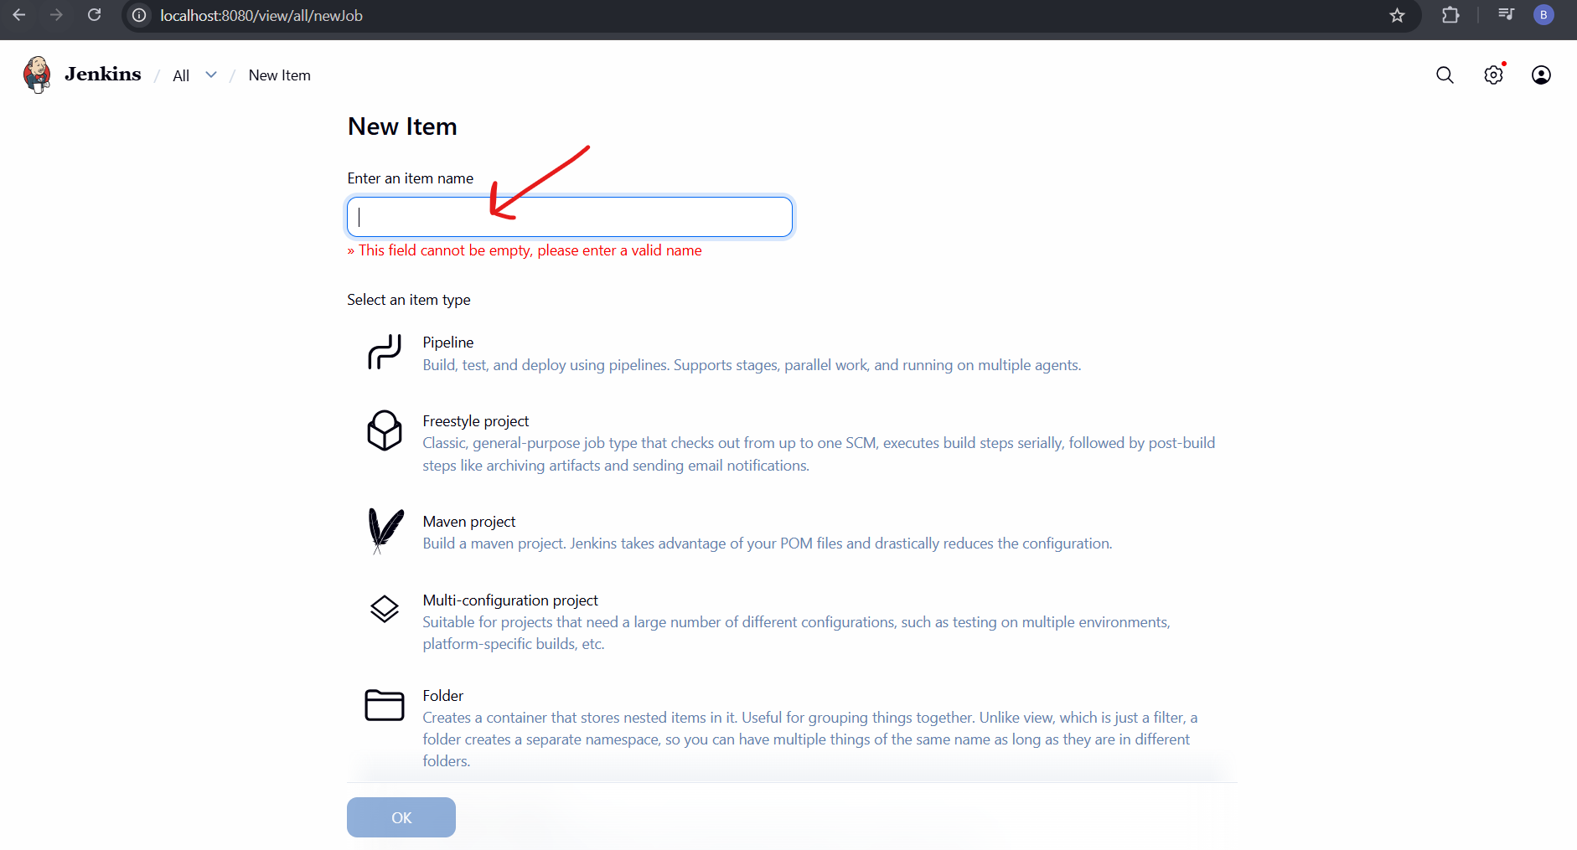
Here you have to give name to pipeline and select item type as “Freestyle Project” then click on “ok”

Step 3: Give general description for pipeline

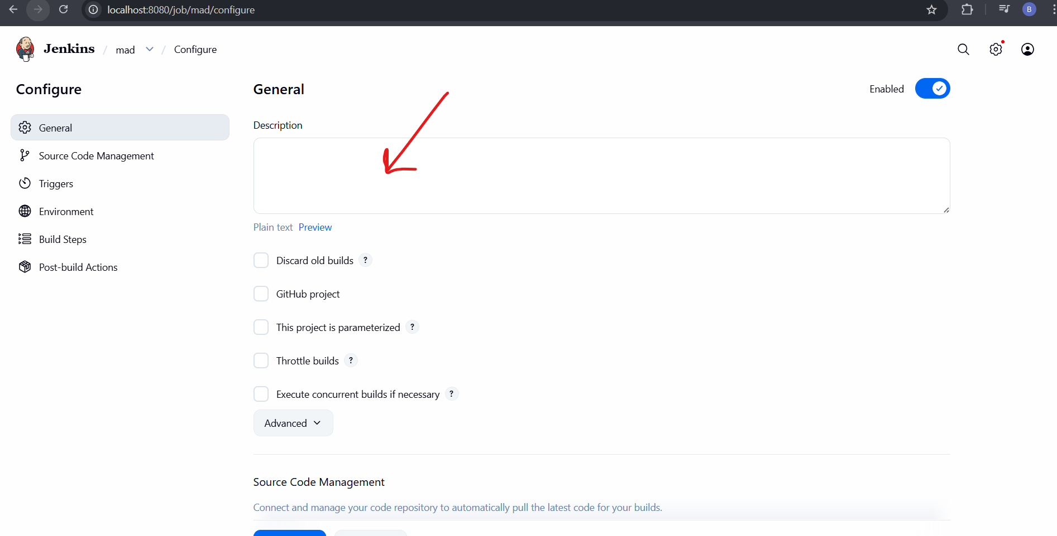
Here you have give general description of pipeline

Step 4: Add project GitHub link

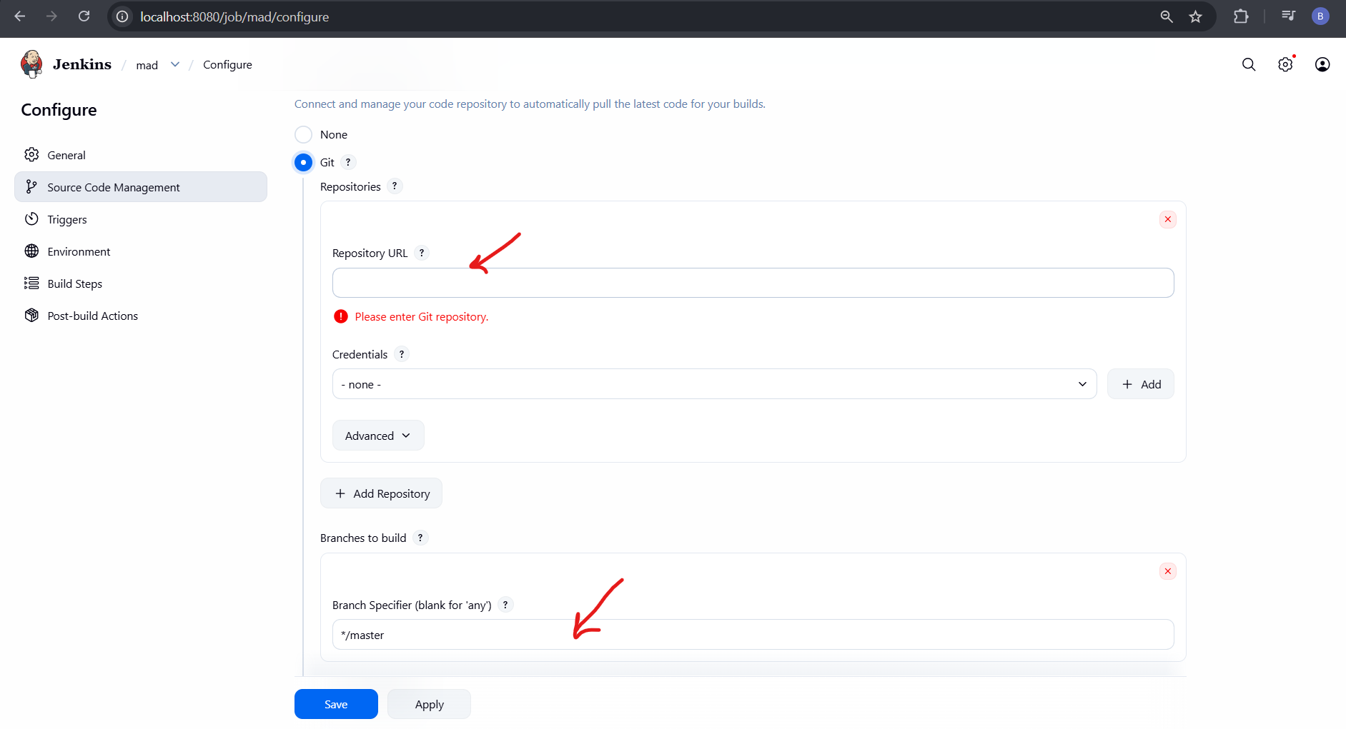
Add project GitHub repository link and also check for branch

Step 5: Build step

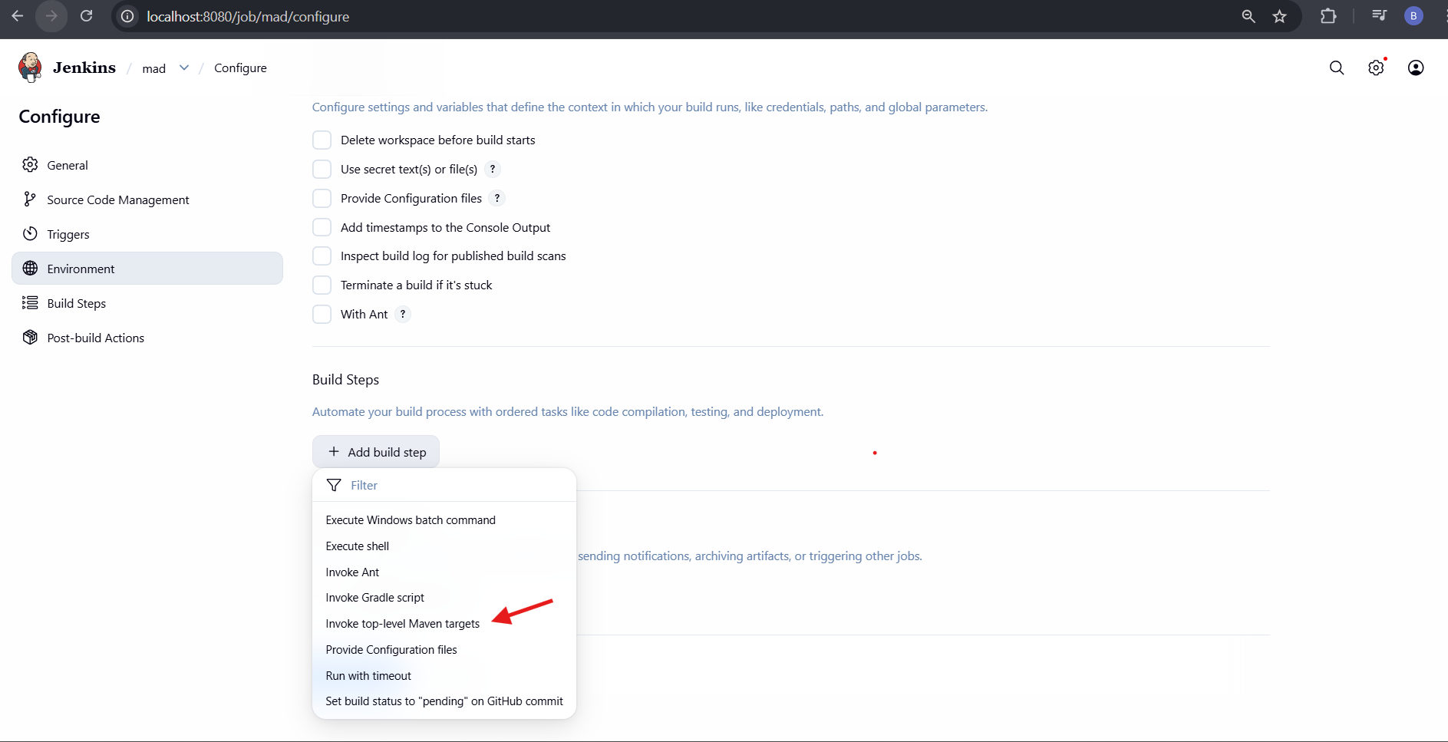
Here choose built step as “Invoke top- level Maven targets”

Step 7: Configure build step

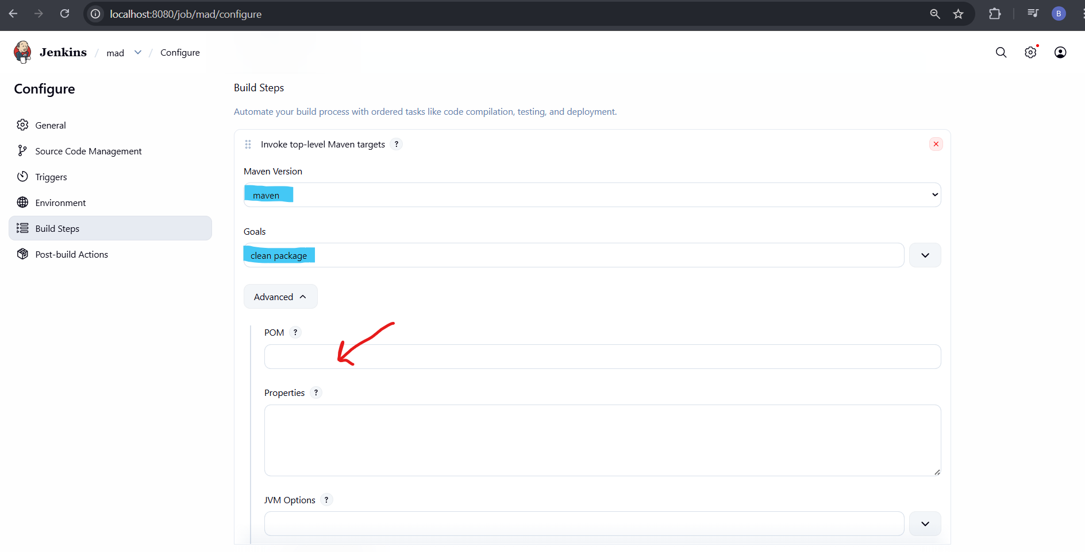
Declare Maven version as “maven” and Goals as “clean package”, and if POM.xml(Project Object Model) file is not in same branch of GitHub then In Advanced section of Build Step add POM.xml file path

Step 8: Post Build Action

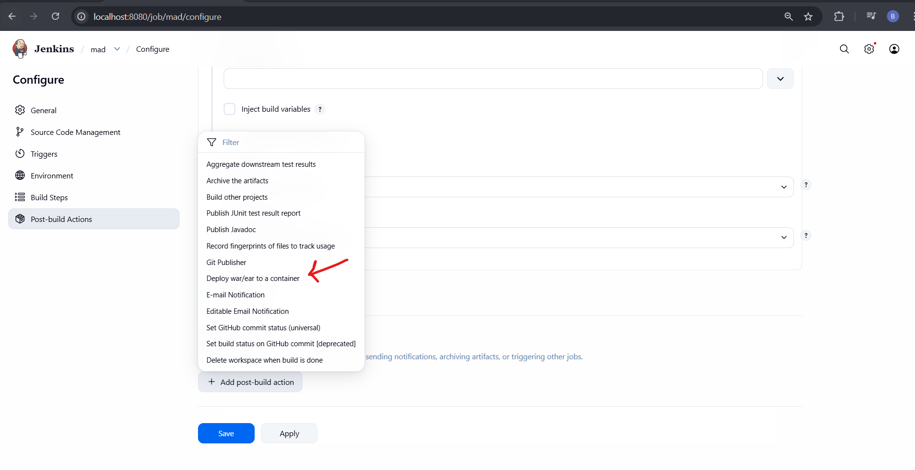
In Post Build Action, add post-build action as “Deploy war/ear to a container”

Step 9: Add war/ ear files

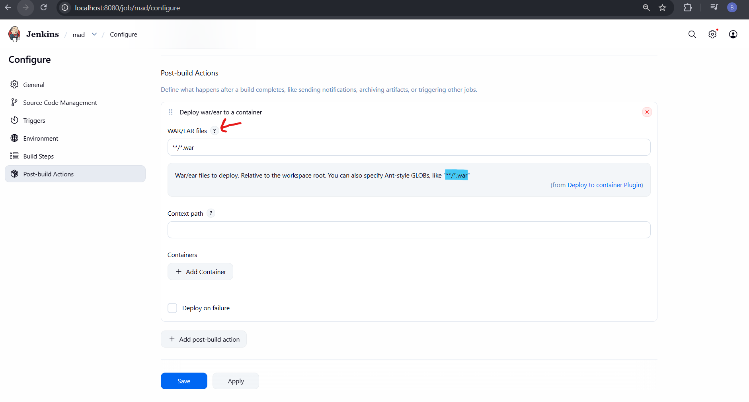
Click on “?” to het war/ ear files, copy text in highlighted blue i.e (**/*.war) and paste it in war/ear files section

Step 10: Add Containers

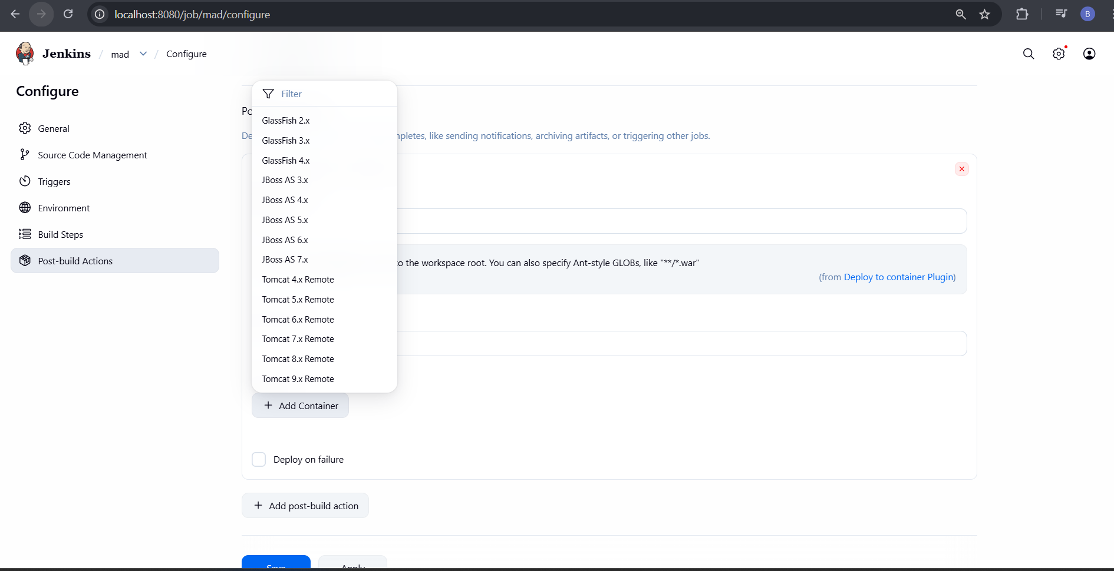
Add Container as Tomcat version which you have downloaded.

Step 11: Add Tomcat Credentials

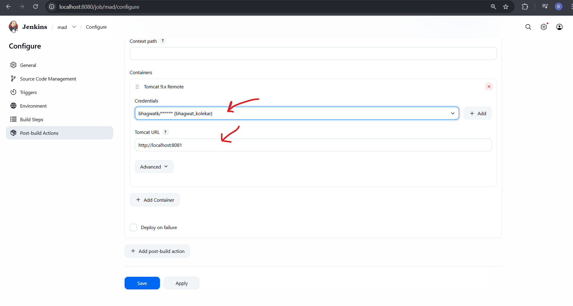
Here I have chosen Tomcat 9 and Given Tomcat account credentials also add Tomcat URL

Step 12: Configure and Build
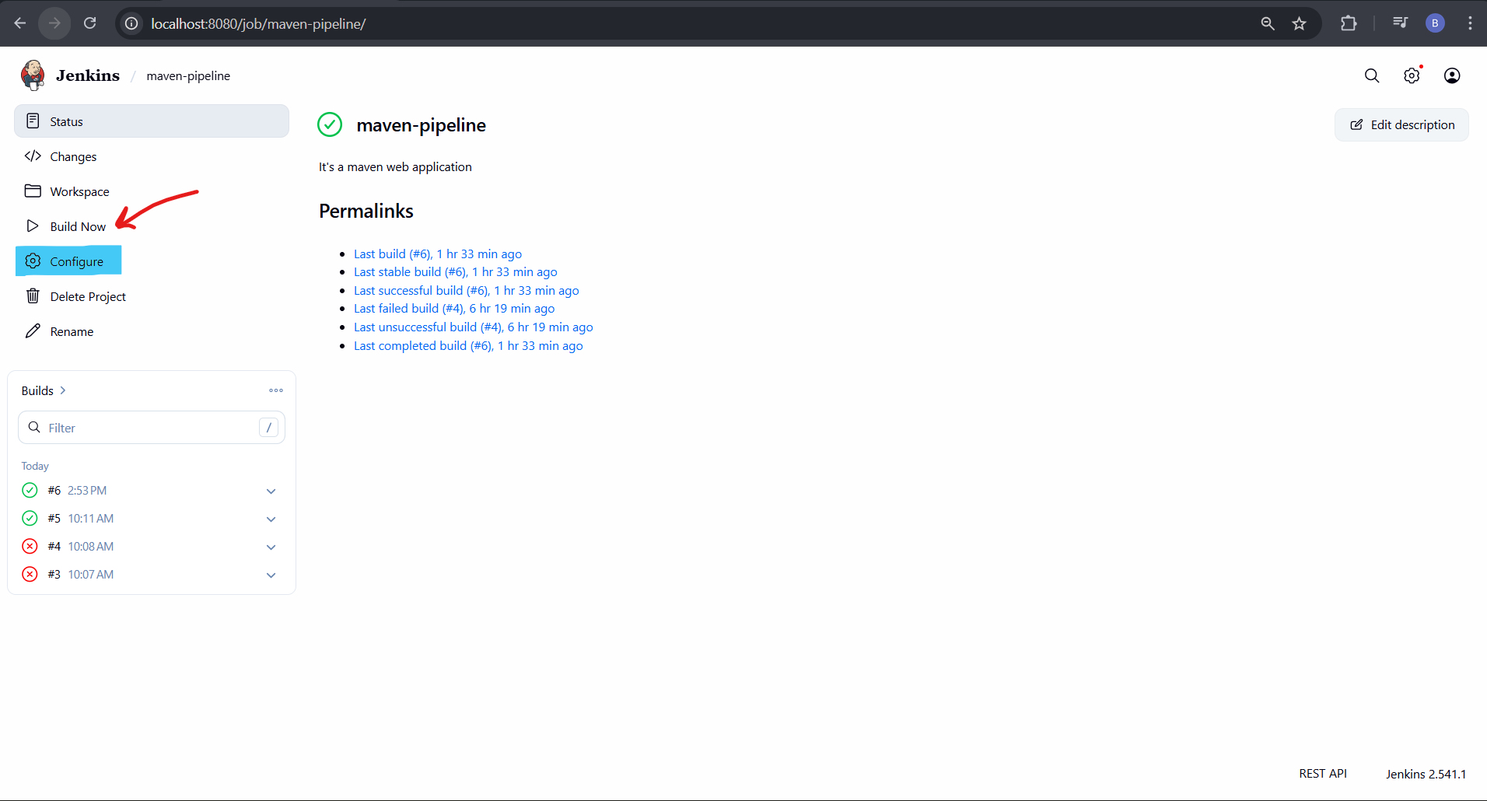

First go to Configure and check all configurations then click on “Build Now”
If Console output is “Success” go to next step otherwise resolve errors.

Step 13: Go to Tomcat Web Application Manager using port number
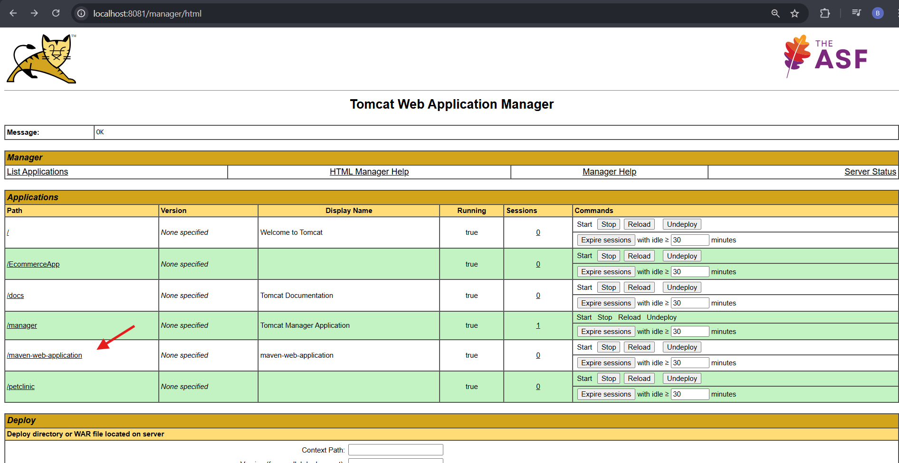
This is the Home Page of Tomcat Web Application Manager, Under Applications Check for “App name”
then click on it

Step 14: Output

